1. We have a digital medium with a data rate of 10 Mbps. How many 64-kbps voice channels can be carried by this medium if we use DSSS with the Barker sequence?
2. Assume that a voice channel occupies a bandwidth of 4 kHz. We need to multiplex 10 voice channels with guard bands of 500 Hz using FDM. Calculate the required bandwidth.

b) What is the maximum size of the data field for a 3-slot Bluetooth frame at basic rate? Explain your answer

3. Frames of 1000 bits are sent over a 1-Mbps channel using a geostationary satellite whose propagation time from the earth is 270 msec. Acknowledgements are always piggybacked onto data frames. The headers are very short. Three-bit sequence numbers are used. What is the maximum achievable channel utilization for (a) Stop-and-wait? (b) Protocol 5? (c) Protocol 6?

4.A data packet of 1200 bytes to be transmitted over a network using the OSI model. The overhead added by each layer is as follows.

1. Layer 1 (Physical Layer): 18 bytes

2. Layer 2 (Data Link Layer): 28 bytes

3. Layer 3 (Network Layer): 36 bytes

4. Layer 4 (Transport Layer): 45 bytes

5. Layer 5 (Session Layer): 8 bytes

6. Layer 6 (Presentation Layer): 10 bytes

7. Layer 7 (Application Layer): 12 bytes

Calculate the total number of bytes in the final frame that will be transmitted over the physical medium.

**SOLUTIONS**

1. We have a digital medium with a data rate of 10 Mbps. How many 64-kbps voice channels can be carried by this medium if we use DSSS with the Barker sequence?

Solution:

To solve this, we need to use the concept of **Direct Sequence Spread Spectrum (DSSS)**, which spreads the signal by a spreading factor derived from the length of the spreading code (in this case, the **Barker sequence**).

**Given:**

* **Data rate of the digital medium**: 10 Mbps
* **Voice channel rate**: 64 kbps
* **Barker sequence**: Typically, the Barker sequence used for DSSS has a length of **11 chips**.

In DSSS, the original signal is multiplied by a spreading code, increasing the bandwidth required. The **spreading factor** (or processing gain) is determined by the length of the Barker sequence. The bandwidth of each voice channel is increased by a factor equal to the length of the Barker sequence.

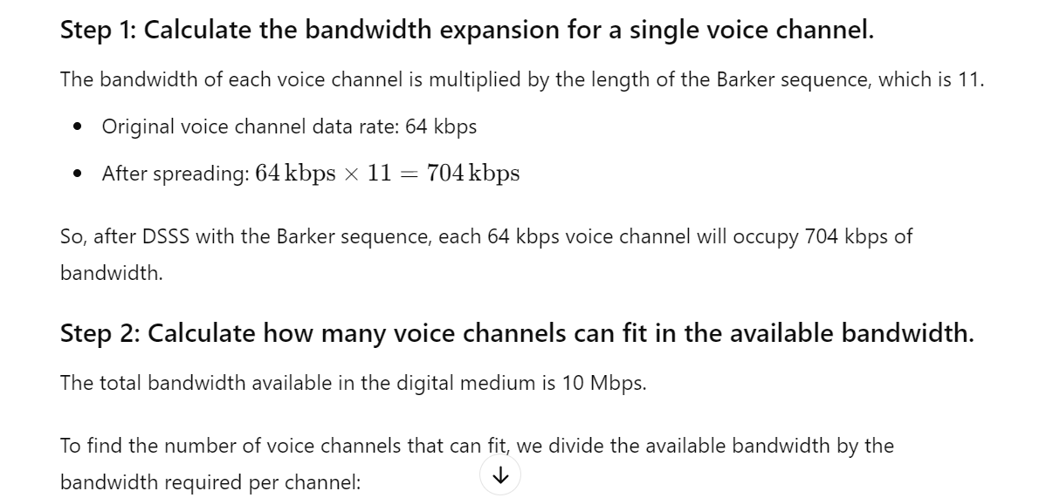

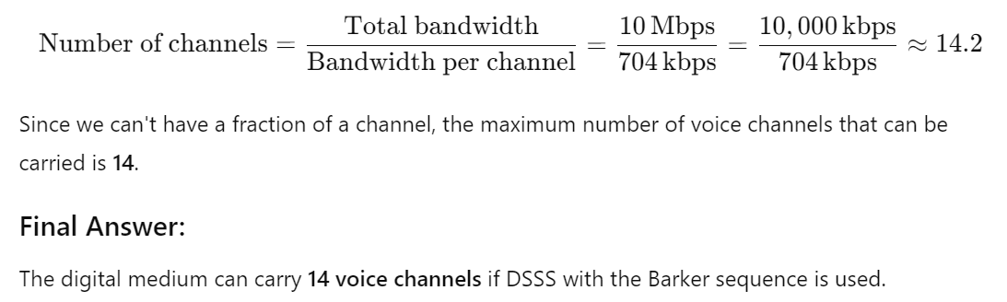

2. Assume that a voice channel occupies a bandwidth of 4 kHz. We need to multiplex 10 voice channels with guard bands of 500 Hz using FDM. Calculate the required bandwidth.

b) What is the maximum size of the data field for a 3-slot Bluetooth frame at basic rate? Explain your answer

SOLUTION: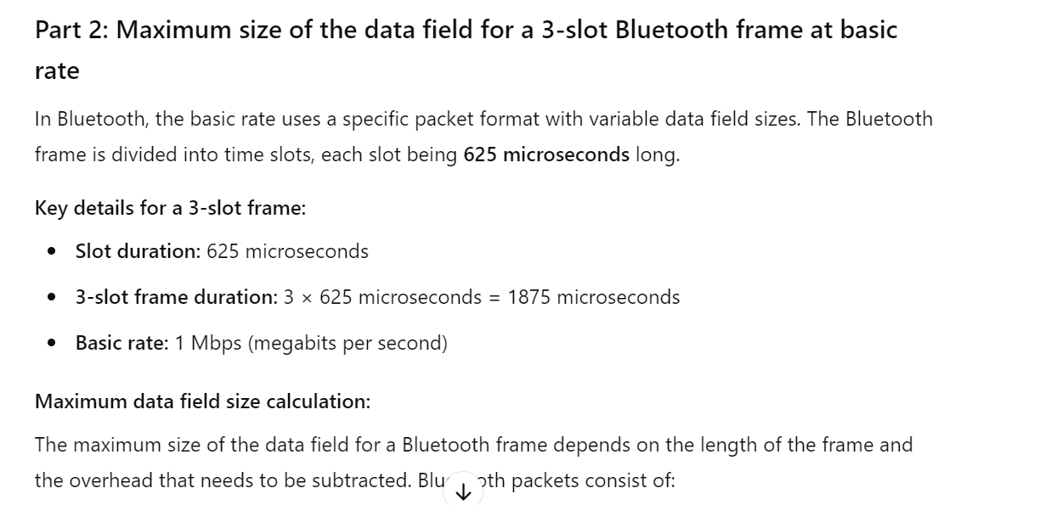 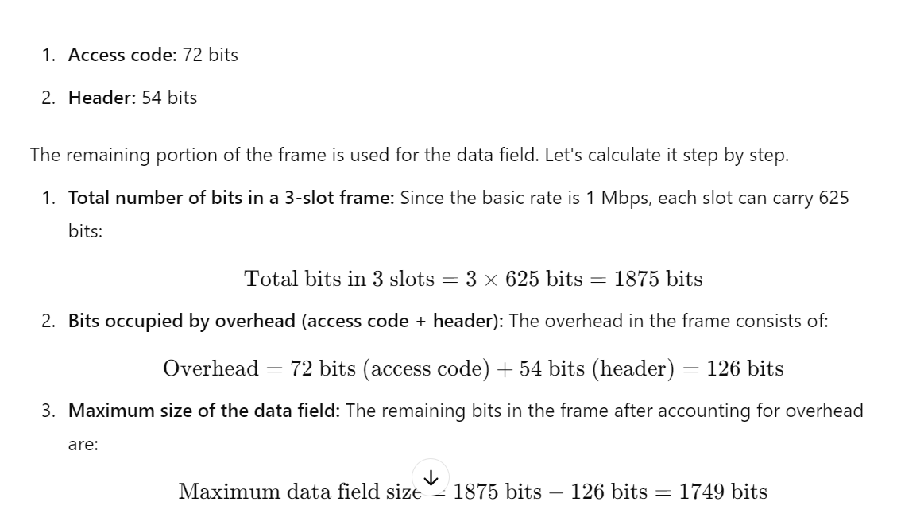

3.Frames of 1000 bits are sent over a 1-Mbps channel using a geostationary satellite whose propagation time from the earth is 270 msec. Acknowledgements are always piggybacked onto data frames. The headers are very short. Three-bit sequence numbers are used. What is the maximum achievable channel utilization for (a) Stop-and-wait? (b) Protocol 5? (c) Protocol 6?

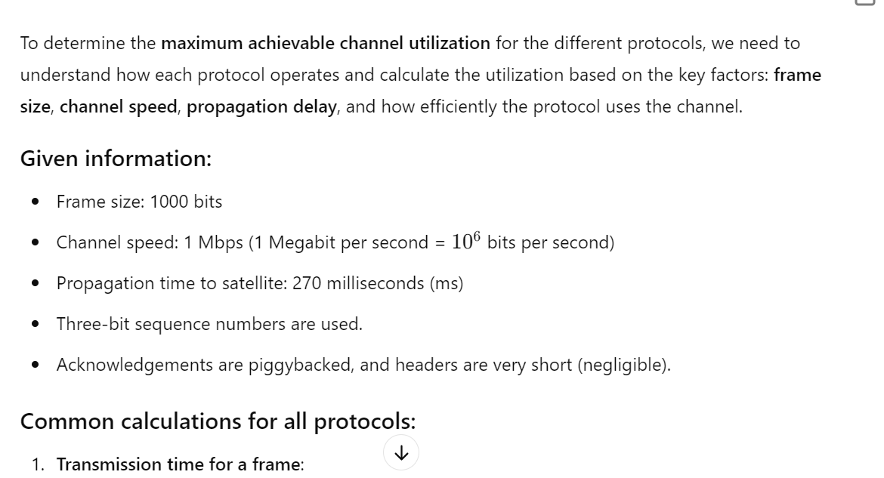 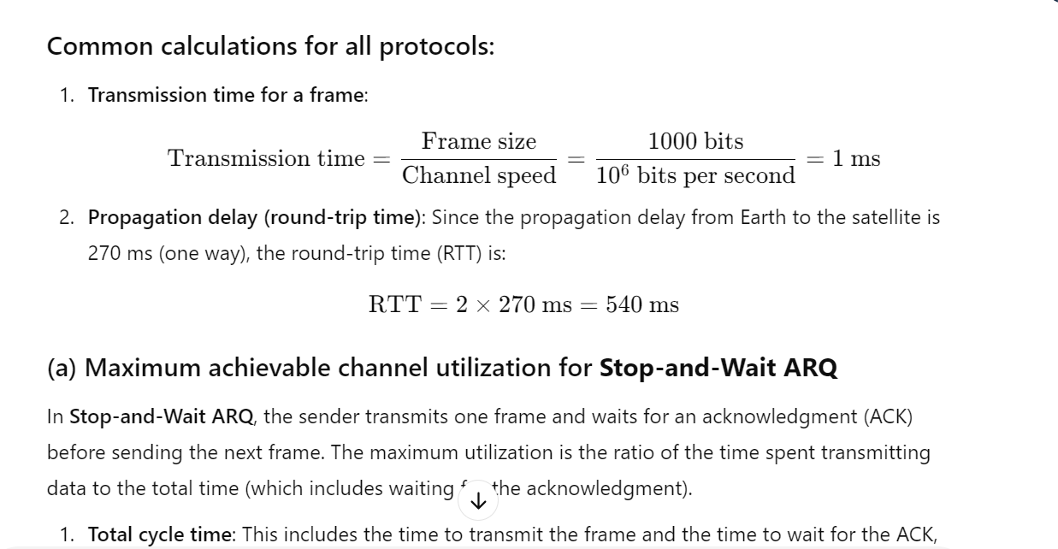 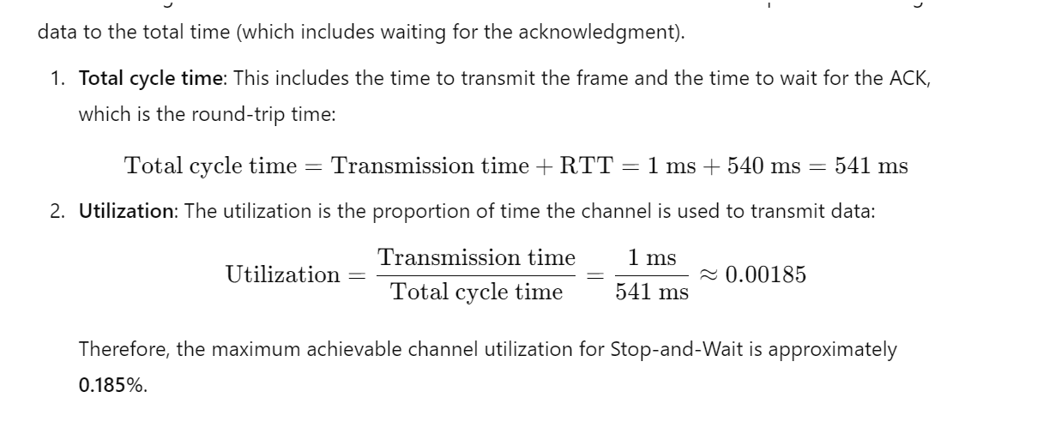 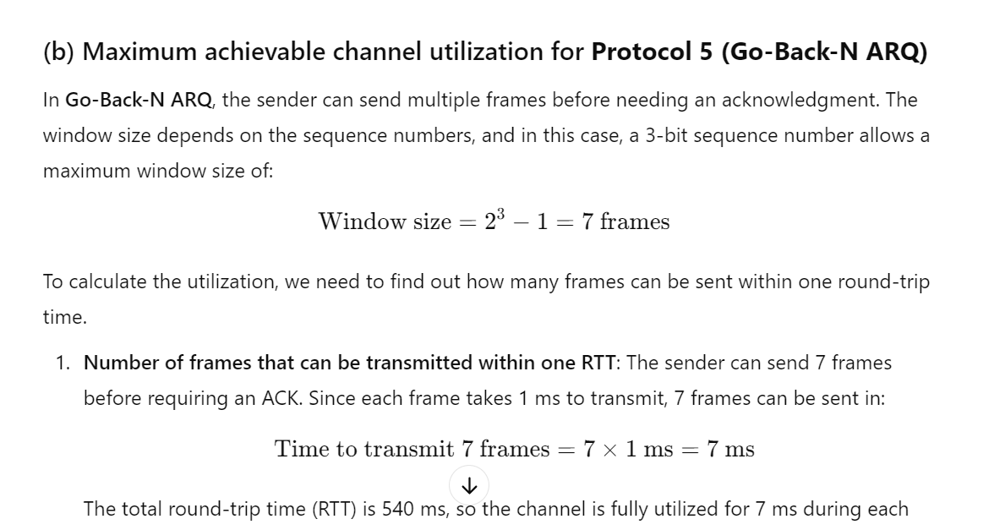 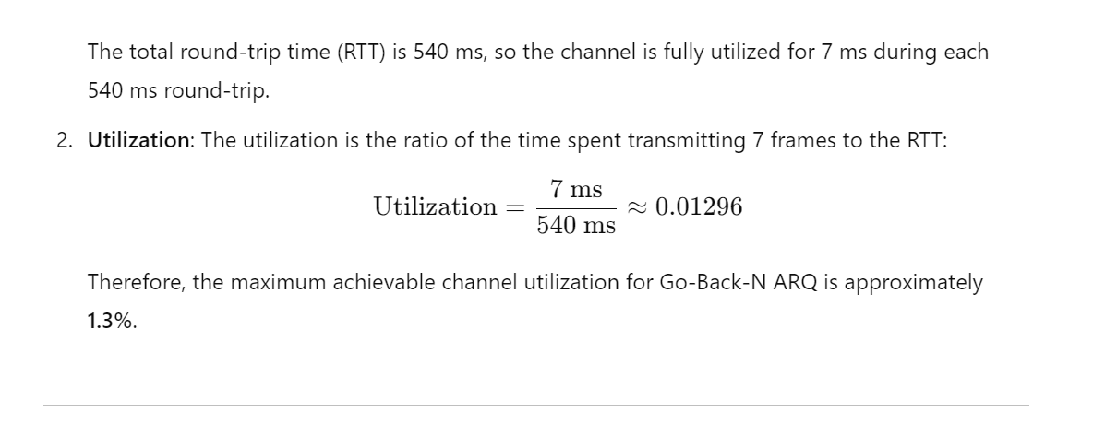 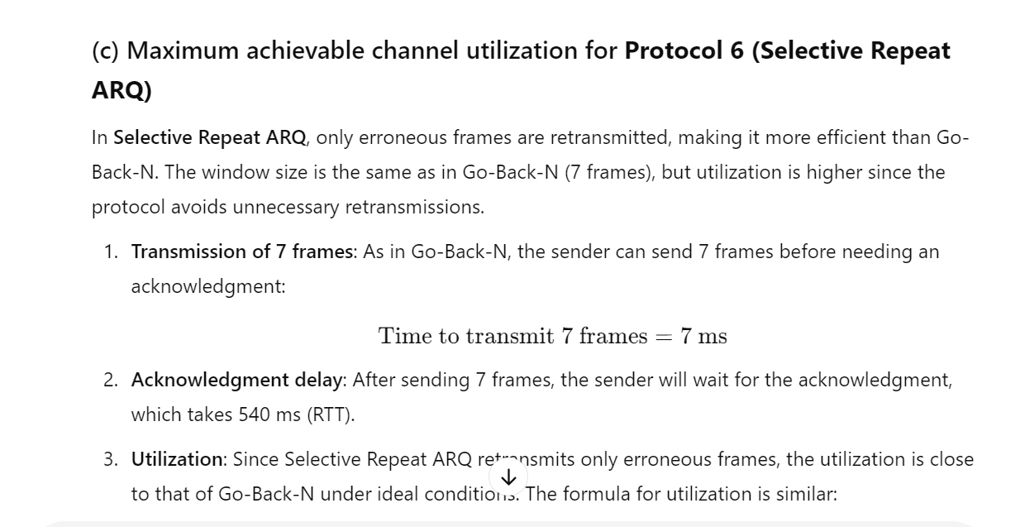

4. 4.A data packet of 1200 bytes to be transmitted over a network using the OSI model. The overhead added added by each layer is as follows.

1. Layer 1 (Physical Layer): 18 bytes

2. Layer 2 (Data Link Layer): 28 bytes

3. Layer 3 (Network Layer): 36 bytes

4. Layer 4 (Transport Layer): 45 bytes

5. Layer 5 (Session Layer): 8 bytes

6. Layer 6 (Presentation Layer): 10 bytes

7. Layer 7 (Application Layer): 12 bytes

Calculate the total number of bytes in the final frame that will be transmitted over the physical medium.

### Given:

* Original data packet size = **1200 bytes**
* Layer 1 (Physical Layer): **18 bytes**
* Layer 2 (Data Link Layer): **28 bytes**
* Layer 3 (Network Layer): **36 bytes**
* Layer 4 (Transport Layer): **45 bytes**
* Layer 5 (Session Layer): **8 bytes**
* Layer 6 (Presentation Layer): **10 bytes**
* Layer 7 (Application Layer): **12 bytes**

### Steps:

1. Start with the original data packet size: **1200 bytes**
2. Add the overheads from all the layers:

Total overhead=18+28+36+45+8+10+12=157 bytes

Add the total overhead to the original data packet size:

Final size=1200+157=1357 bytes

### Final answer:

The total number of bytes in the final frame that will be transmitted over the physical medium is **1357 bytes**.